LoRa MQTT based Smart Farm

Hye Won Yoon  
*Dept. of Software Convergence*  
*Kyunghee University*Yong In, South Korea  
yhye97@khu.ac.kr

Chaehee Weon  
*Dept.of Software Convergence*  
*Seoul Women's University*Seoul, South Korea  
1chaehui@swu.ac.krDong Jun Kim  
*Dept. of Software Convergence*  
*Kyunghee University*Yong In, South Korea  
mirsol189@khu.ac.kr

Anthony Smith  
*Computer Information Technology*  
*Purdue University*West Lafayette, USA  
ahsmith@purdue.eduMiran Lee  
*College of Engineering*  
*Dongguk University*Seoul, South Korea  
rannan09@dongguk.edu

*Abstract*— *Smart farms are the future of Agriculture. They are expected to increase the productivity with low-cost and high convenience. Nevertheless, farmers are skeptical of running smart farms, due to its expensiveness, inefficient energy consumption, difficult management and potential data leakage. Many studies suggest using LoRa (Long Range), a type of LPWAN (long power wide area network) technology, which is capable of long range with economical price and small battery consumption. However, studies overlook on how to transmit data proficiently, safely and assuredly. Therefore, this study proposes a LoRa and MQTT (Message Queue Telemetry Transport) based smart farm. MQTT is a lightweight messaging protocol that guarantees reliability and security of data while minimizing the wastage of packet space. The prototype uses two Arduino Board with Dragino LoRa Hat, in which one is connected to VH400 soil moisture sensor, and DHT11 temperature and humidity sensor, and the other connected to a solenoid valve irrigation actuator. There is a Raspberry Pi irrigation node, which uses Open Weather API to get 5 days forecast data. Lastly, deployed a web-based application for farmers to conveniently manage the smart farm.*

***Keywords——Smart Farm, LoRa, MQTT, IoT***

# Introduction

According to the Food and Agriculture Organization of the United Nations, the definition of “Smart Farming is a farming management concept using modern technology to increase the quantity and quality of agricultural products” [1]. Smart farms play a big role on achieving precision agriculture, also known to be the future of agriculture [2]. It monitors soil, irrigation, and weather conditions in order to increase the productivity [3].

For example, smart farms collect vital agriculture data such as soil moisture, temperature, and humidity using IoT (Internet of Things) sensor technology [4]. Weather forecast data-gathering is performed using open-source weather API (Application Programming Interface)s, in which Big Data technology being the key foundation [5]. Data analysis is done for the optimization and modification of the surrounding environment and predict when the crops need water [6]. Finally, manipulating the data in an online interface, farmers can conveniently manage their smart farm anywhere at any time.

However, there are still many obstacles smart farms yet to overcome. [7] carried out a survey of research activities in smart farming, and pointed out that incentives, investments, innovative tools, data, network, and information are the barriers smart farms must conquer. They mentioned that not only is low-cost a key factor in smart farming, energy efficiency, convenience on management, data transmission, and assurance of high security and reliability. are also important factors to consider.

Consequently, the decision making of the network technology is crucial. LPWAN (long power wide area network) is a popular wireless communication network technology for IoT applications, due to small power consumption, high coverage, and inexpensive communication features [8]. Sigfox, NB-IoT, and LoRa(Long Range) are the three highly favored technologies of LPWAN. [8] conducted a study to compare the three technologies in different IoT deployments and concluded Sigfox and LoRa are the most appropriate for smart farms.

Nevertheless, there weren’t any studies which focused on the messaging protocols for smart farms. The size of the data received from soil moisture, temperature, humidity sensors is very small. Hence, in order to efficiently transmit data, minimizing the wastage of packet space is necessary. In addition, the reliability and security of the data transmission must be guaranteed. There are several IoT communication protocols (e.g. DPWS, XMPP, CoAP), but MQTT (Message Queue Telemetry Transport) is most adequate for IIoT (Industrial IoT) applications [9].

MQTT is an extremely lightweight messaging protocol. As stated in [10], “the design principles of MQTT is to minimize network bandwidth and device resource requirements whilst also attempting to ensure reliability and some degree of assurance of delivery”. MQTT has just 4 bytes of fixed header overhead and is the only IoT protocol which has QoS (Quality of Service) options up to 3 levels [9].

Therefore, this study proposes a smart farm based on LoRa and MQTT, which meets the criteria of smart farms mentioned above.

The remainder of the study is organized as follows: Section 2 compares the previous works that have been done on LoRa and MQTT. Section 3 explains the methodology of building a LoRa and MQTT based smart farm. Section 4 explains how to implement the smart farm. Section 5 explains the result of our prototype. Lastly, Section 6 concludes the paper.

# Related Work

## LoRa

Sarker et al. [11] demonstrated the benefits of applying LoRa technology to the IoT. Furthermore, they have demonstrated that using an integration of cloud and edge computing is more appropriate than just using cloud computing in the LoRa IoT environment, reducing waste of resources.

Muangprathub et al. [6] proposed a system to control environmental factors in crop fields. And they implemented web application and mobile application, it allowed for automatic and manual control. However, they used only WiFi of the NodeMCU, which has a voltage of 135-215 mA. Our study is using LoRa network to develop a more efficient system in terms of power consumption.

Ko et al. [12] demonstrated through experiments that LoRa was the most efficient among many LPWAN protocols and found the optimal PHY configuration setting on the LoRa network. They also found that the variation of tree farms was bigger than the variation of open area and that the RSSI's Variation was more consistent in the tree farm than an open area.

## LoRa and MQTT

Spinsante et al. [13] proposed a system for building automation services using LoRa and MQTT. This study verified that LoRa suits well in indoor scenarios, and the use of MQTT fulfilled the real-time requirements of the building automation service.

Huang et al. [14] proposed a marine wireless sensor network monitoring system based on LoRa and MQTT. This study proved that even though the sensor packages are in outdoor water environment, the data from sensors don’t affected significantly if the whole set of equipment is within a certain coverage of the wireless signal.

Kodal et al. [15] proposed a smart IoT farm model based on LoRa. Similar to our study, the system uploads data to the cloud using the MQTT protocol, but this system only has the monitoring part.

# Methodology

This work aims to design a smart farm that fulfills all the key factors mentioned in Section 1 and allow farmers to conveniently manage their smart farm by using web-based application.

## Required Components

1. Required Sensors

|  |  |
| --- | --- |
| **Parameter** | **Sensors / Value** |
| Temperature and Humidity | DHT11 |
| Soil Moisture | VH400 |
| Solenoid Valve | 0~0.8MPa |
| Relay Module | High level trigger |

1. DHT11 Features

|  |  |
| --- | --- |
| Operating Voltage | 3.5V to 5.5V. |
| Operating current | 0.3mA (measuring) 60uA (standby) |
| Output | Serial data. |
| Temperature Range | 0°C to 50°C. |
| Humidity Range | 20% to 90% |
| Resolution | Temperature and Humidity both are 16-bit. |
| Accuracy | ±1°C and ±1% |

1. Vh400 Features

|  |  |
| --- | --- |
| Power consumption | < 13mA |
| Supply voltage | 3.5V to 20 VDC. |
| Power on to Output stable | 400ms |
| Output Impedance | 10K ohms |
| Operational temperature | -40ºC to 85ºC |
| Accuracy at 25°C | 2% |
| Output | 0 to 3V related to moisture content |
| Shell color | Red |
| Voltage Output Curves | [Curves](https://www.vegetronix.com/Curves), [Piecewise linear equations](https://www.vegetronix.com/Products/VH400/VH400-Piecewise-Curve.phtml) |
| Certifications | [CE Declaration of Conformity](https://www.vegetronix.com/Products/VH400/VH400-RoHS-Declaration.pdf) |

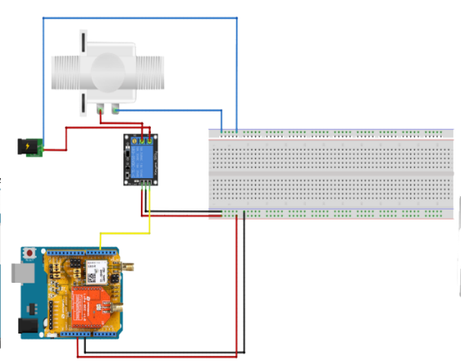

1. Circuit of Sensor Node

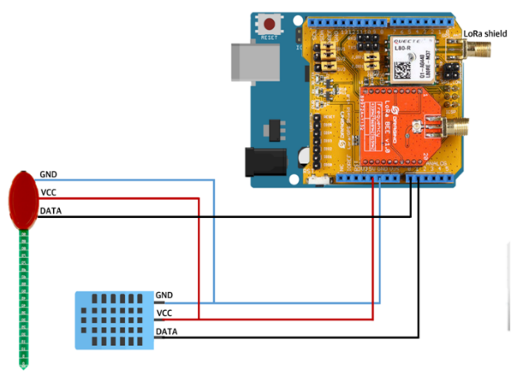

1. Circuit of Actuator Node

The sensors required are DHT11, VH400, Solenoid Valve, and a relay module, as shown in Table 1. DHT11 sensor receives soil humidity and temperature, and has the features as shown in [16, Table 2]. VH400 sensor receives soil moisture data, and has features as shown in [17, Table 3]. In the sensor node, as shown in Fig. 1., the LoRa/GPS shield of Dragino is attached to the Arduino and is connected with DHT11 and VH400. Raspberry Pi with a LoRa/GPS Hat is used as a gateway. Edge computing node for the irrigation is also a Raspberry Pi. The actuator node is attached to Arduino to LoRa/GPS shield of Dragino and is operated by the relay module of the high-level trigger and the solenoid valve, as shown in Fig. 2.

## B. System Design

The overall system design of the smart farm includes six components, as shown in Fig. 3.

1. Design of Smart Farm based on LoRa and MQTT.

The first component is sensors. These sensors obtain soil moisture, temperature, and humidity data from soil and air. The sensors used in this project are shown in Table 1., and the circuit of the sensor node is shown in Fig. 1.

The second component is gateway. This gateway is a Raspberry Pi with a Lora/GPS Hat, and registered in TTN (The Things Network) Cloud. It receives sensor data by Lora RF, LoraWAN, and sends it to the TTN Cloud. Also, receives data from irrigation node and web-based application and decides whether to send signal to actuator using LoRa RF and LoRaWAN.

The third component is TTN Cloud. TTN Cloud is a cloud that connects and manages exchange data from LoRa gateways [18]. When TTN Cloud receives data from the packet forwarder and uplinks to the web-based application. In addition, TTN Cloud is integrated with Cayenne, an interface for the administrator.

The fourth component is an irrigation node. This node is a Raspberry Pi which runs an Open Weather API. Open Weather API is an open-source weather API that allows to get 5 days weather forecast.

The fifth component is actuators. This actuator is a solenoid valve that is connect to an Arduino. This valve is turned on automatically when the soil moisture is under 200. (soil moisture range). Moreover, it can be turned on/off by the farmer’s decision.

The sixth component is a web-based application. The backend development was done by using Node JS, frontend using HTML/CSS, database using MySQL version 5.6. The web-based application's design was RWD (responsive web design), in order to meet farmers’ needs to use the application on various devices, e.g. computers and smartphones.

## C. MQTT Diagram

There are three MQTT diagrams that is used in the system design, as shown in Fig. 3. The diagrams for the actuator activating automatically due to the soil moisture are shown in Fig. 4. and 5. The diagram for the actuator activating manually from the web-based application is shown in Fig. 6.

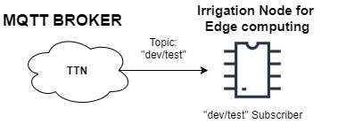

1. MQTT Diagram of Controlling Actuator Automatically- sending data to irrigation node

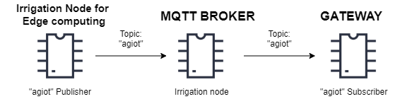

1. MQTT Diagram of Controlling Actuator Automatically- sending data to actuator

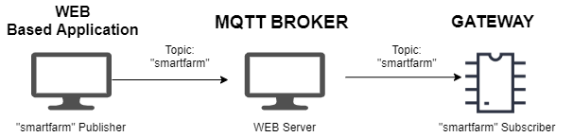

1. MQTT Diagram of Controlling Actuator by Farmer’s Decision

First, when sending the sensor data to the irrigation node, as shown in Fig. 4. TTN Cloud acts as a MQTT Broker. Irrigation node for edge computing act as a subscriber for “dev/test” topic. After appending data from the Open Weather API, it sends it to the LoRa gateway as shown in Fig. 5. The irrigation node, the Raspberry pi with Mosquitto Broker installed, is the publisher of “agiot” and act as the MQTT Broker. The LoRa gateway is the subscriber of the topic “agiot”, which receives the sensor data and weather data in a string.

In Fig. 6., web-based application is a MQTT publisher of the topic “smartfarm”. The gateway, the subscriber of “smartfarm” receives the farmer’s decision and sends it to the actuator by LoRa. The broker for this diagram is Eclipse Mosquitto, an open source message broker [19].

# VI. Implementation

## A. Flowchart

Fig. 7. shows the flowchart of the Arduino receiving humidity and temperature data from DHT11 and soil moisture data from VH400, displaying the data, and sending packet by LoRa.

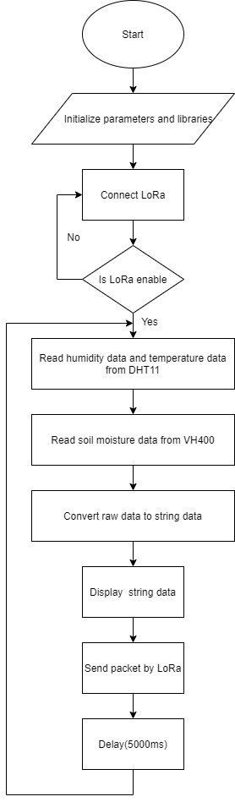

1. Flowchart of sensor node

Fig. 8. shows the flowchart of the gateway i.e., data transmitter received from sensor node to TTN Cloud, data transmitter received from irrigation node to actuator node, and data transmitter received from local server to actuator node.

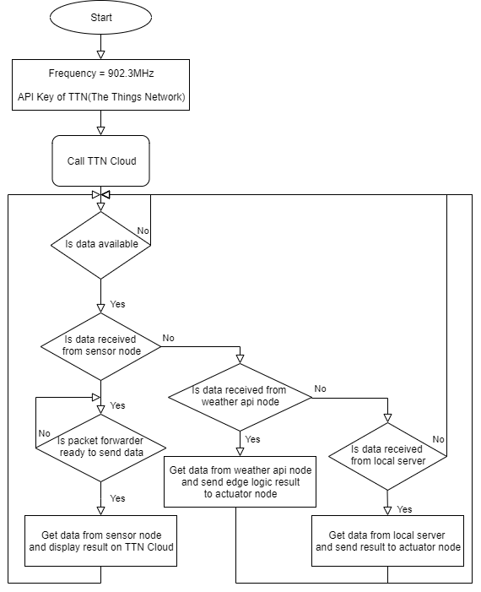

1. Flowchart of gateway

Fig. 9. shows the flowchart of the irrigation node. When the irrigation node gets sensor data from MQTT Broker, the irrigation node gets weather data from Open Weather API and add that data to the sensor data. Finally, the data is sent to the gateway.

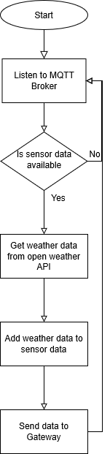

1. Flowchart of irrigation node

Fig. 10. shows the flowchart of the actuator node, which the initial settings must be finished, as shown in Fig. 2. The actuator node receives data from the gateway. It turns on the actuator when it receives ‘1’ and turns it off when the data is ‘0’.

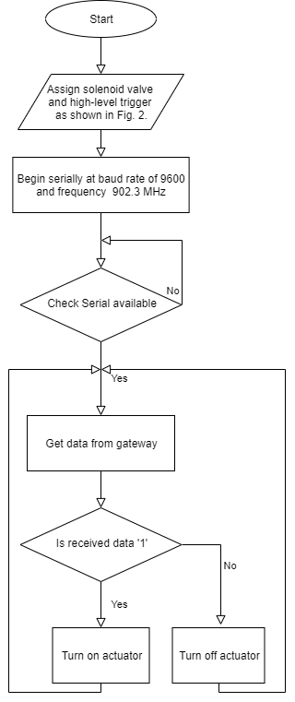

1. Flowchart of Actuator Node

### B. Scenario

Fig.11. shows a scenario when the user operates the actuator manually using a web-based application. The user controls on or off via web-based application. On the web-based application, the user's control is published to the broker Mosquitto, and the gateway subscribes to that information. The gateway sends a signal to the actuator using LoRa to turn the actuator on or off. Gateway responds to the changed actuator status and updates in the database. Finally, the changed result is reflected in the web-based application and the result is shown to the user.

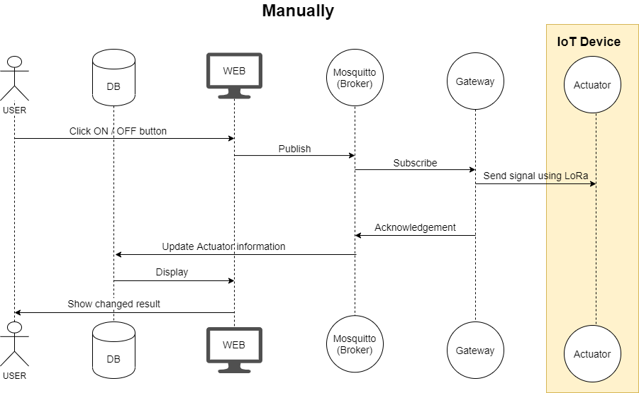

1. Actuator operation scenario when the user manually controls

Fig. 12. shows a scenario when the actuator is operated automatically without user control. The sensor node sends the soil moisture value to the gateway. The gateway uplinks to the TTN and the TTN downlinks to the irrigation node, which is an edge node. Since this node has five-day weather forecast information, it sends the weather information and the soil moisture value to the gateway. The gateway uses these values and send on or off signal to actuator. Above process is repeated at regular intervals.

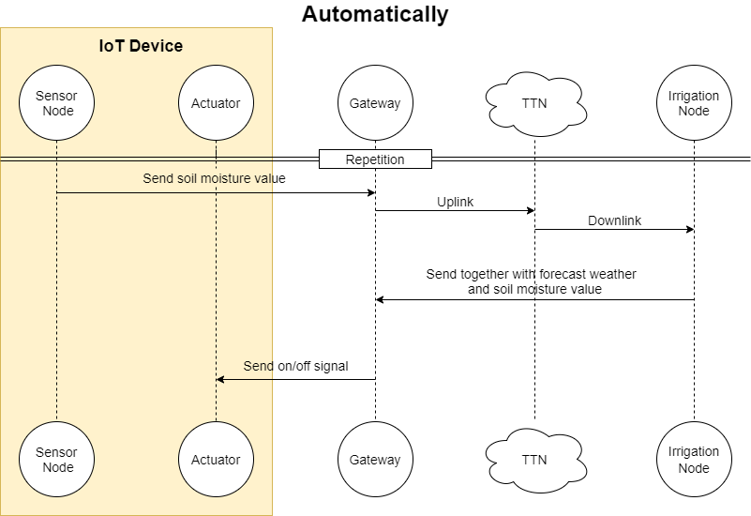

1. Automatically actuator operation scenario

# V. Result

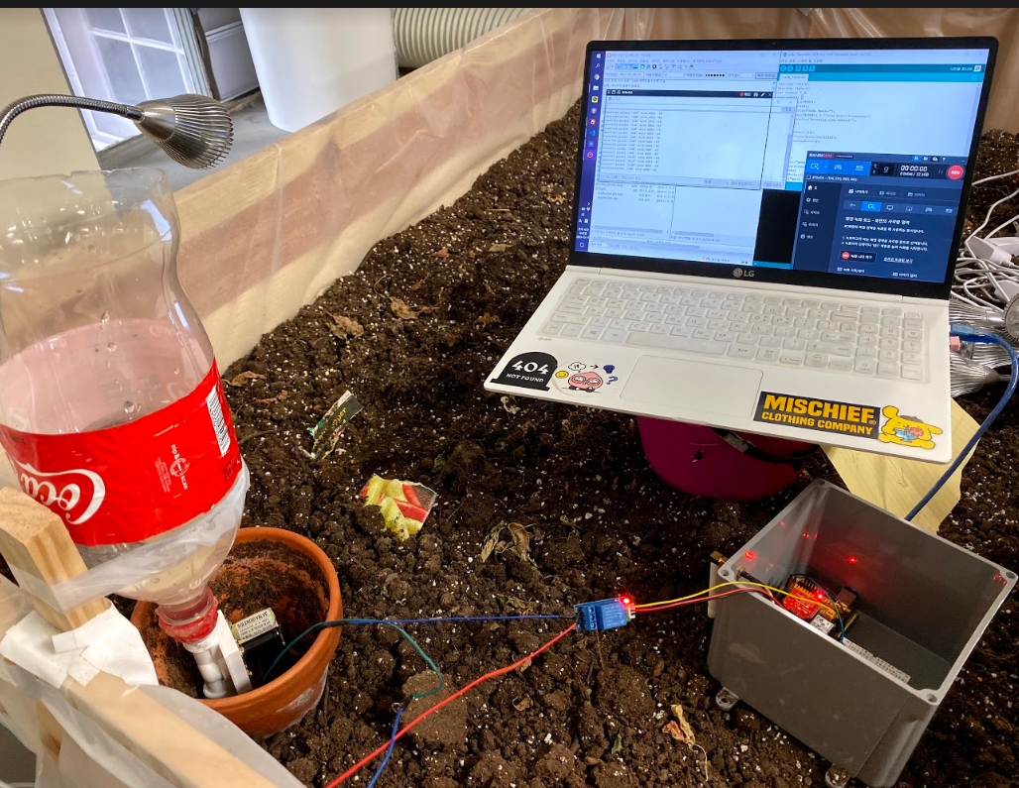

1. Prototype Environment

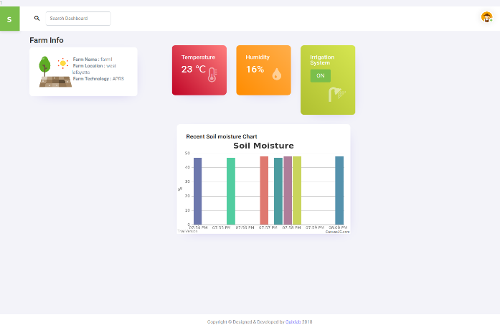

1. My Farm Page

The prototype was designed before installation on the farm, as shown in Fig.13. The prototyping environment was conducted in a small garden 1.2 m * 2.0 m in the K-SW Square of Purdue University. The web server operated on a local server.

Fig. 14. is the web-based application’s my farm page. This page shows temperature, humidity, soil moisture data which was collected from the sensors installed at the smart farm. There is an irrigation “ON/OFF” button, which shows whether the actuator is turned “ON/OFF”. When the farmer clicks on the button, the actuator can be activated manually.

# VI. Conclusion

This paper presented a LoRa and MQTT based smart farm system monitoring condition of soil and air. The data from Identify applicable funding agency here. If none, delete this text box. Sensors are transferred over LoRa and it is sent directly to TTN Cloud. From TTN Cloud, data is transferred by MQTT protocol. The signal for actuator node is sent by LoRa. The farmers can directly access the monitoring result on the web-based application and control the actuator. Under excessively dry condition for the crop, the edge logic for irrigation can decide turning on or off the actuator by referring the data which is from the sensors and weather data from weather API. The signal is sent over LoRa to the actuator node. However, because of intervention of the TTN Cloud, necessity of edge computing logic is faded. Since the quality of internet connection at outdoor is not stable, and irrigation needs to be available for any time, entire ecosystem if required to keep controlling the irrigation system even though internet connection is lost.

For future work, building the entire ecosystem running without internet connection could guarantee irrigation system to keep the good condition for crops. Moreover, since entire system was built and tested indoor, actual feasibility of this system could be verified by implementing it on an outdoor farm.

##### Acknowledgment

##### This research was supported by the MSIT (Ministry of Science and ICT), Korea, under the National Program for Excellence in SW(R7116-16-1014) supervised by the IITP (Institute for Information & communications Technology Promotion).

##### References

1. “*BLOG: Smart Farming is the key for the future of agriculture”*, Schuttelaar & Partners , June. 2017. Accessed on: Dec. 10, 2019. [Online]. Available: <https://www.schuttelaar-partners.com/news/2017/smart-farming-is-key-for-the-future-of-agriculture>
2. S. Wolfert, D. Goense and C. A. G. Sørensen, "A Future Internet Collaboration Platform for Safe and Healthy Food from Farm to Fork," *2014 Annual SRII Global Conference*, San Jose, CA, 2014, pp. 266-273.
3. P. Jayaraman, A. Yavari, D. Georgakopoulos, A. Morshed, A. Zaslavsky. “Internet of Things Platform for Smart Farming: Experiences and Lessons Learnt” in *ResearchGate,* Nov. 2016 [Online]. Available: <https://www.researchgate.net/publication/309894257_Internet_of_Things_Platform_for_Smart_Farming_Experiences_and_Lessons_Learnt>
4. M. Lee, J. Hwang and H. Yoe, "Agricultural Production System Based on IoT," *2013 IEEE 16th International Conference on Computational Science and Engineering*, Sydney, NSW, 2013, pp. 833-837.
5. S. Wolfert, L. Ge, C. Verdouw, M. Bogaardt, “Big Data in Smart Farming – A review”in *ScienceDirect*, Feb. 2017 [Online]. Available : <https://www.sciencedirect.com/science/article/pii/S0308521X16303754>
6. J. Muangprathub, N. Boonnam, S. Kajornkasirat, N. Lekbangpong, A. Wanichsombat, P. Nillaor, “IoT and agriculture data analysis for smart farm” in *ScienceDirect,* Dec. 2018 [Online]. Available : <https://www.sciencedirect.com/science/article/pii/S0168169918308913>
7. M. Bacco, P. Barsocchi, E. Ferro, A. Gotta, M.Ruggeri., “The Digitisation of Agriculture: a Survey of Research Activities on Smart Farming” in *ScienceDirect*, Nov.2019. [Online]. Available: <https://www.sciencedirect.com/science/article/pii/S2590005619300098>[t](https://www.researchgate.net/publication/322018958_A_comparative_study_of_LPWAN_technologies_for_large-scale_IoT_deployment)
8. K. Mekki, E. Bajic, F. Chaxel, F. Meyer.,. “A comparative study of LPWAN technologies for large-scale IoT deployment” in *ResearchGate*, Mar.2019. [Online]. Available: <https://www.researchgate.net/publication/322018958_A_comparative_study_of_LPWAN_technologies_for_large-scale_IoT_deployment>
9. S. Katsikeas et al., "Lightweight & secure industrial IoT communications via the MQ telemetry transport protocol," *2017 IEEE Symposium on Computers and Communications (ISCC),* Heraklion, 2017, pp. 1193-1200.
10. *"FAQ - Frequently Asked Questions | MQTT",* MQTT.org, Accessed on : Sept. 20 , 2019.[Online]. Available: <http://mqtt.org/faq>
11. V. K. Sarker, J. P. Queralta, T. N. Gia, H. Tenhunen and T. Westerlund, "A Survey on LoRa for IoT: Integrating Edge Computing," *2019 Fourth International Conference on Fog and Mobile Edge Computing (FMEC)*, Rome, Italy, 2019, pp. 295-300.
12. S. Ko *et al*., "LoRa network performance comparison between open area and tree farm based on PHY factors," *2018 IEEE Sensors Applications Symposium (SAS)*, Seoul, 2018, pp. 1-6.
13. S. Spinsante, “A LoRa Enabled Building Automation Architecture Based on MQTT,” *2017 AEIT International Annual Conference*, Cagliari, Italy, 2017, pp. 1-5
14. A. Huang, M. Huang, Z. Shao, X. Zhang, D. Wu, C. Cao, “A Practical Marine Wireless Sensor Network Monitoring System Based on LoRa and MQTT," *2019 IEEE 2nd International Conference on Electronics Technology (ICET)*, Chengdu, China, 2019, pp. 330-334
15. R. Kodali, S. Yerroju, S. Sahu, “Smart Farm Monitoring Using LoRa Enabled IoT,” *2018 Second International Conference on Green Computing and Internet of Things (ICGCIoT)*, Bangalore, India, 2018, pp. 391-394
16. *“*DHT11 Sensor Pinout, Features, Equivalents & Datasheet*”,* Components101.com Accessed on : Sept. 9 , 2019.[Online]. Available: [**https://components101.com/dht11-temperature-sensor**](https://components101.com/dht11-temperature-sensor)
17. *“*Soil Moisture Sensor - VH400*”,* Vegetronix.com, Accessed on : Sept. 9 , 2019.[Online]. Available: [**https://www.vegetronix.com/Products/VH400/**](https://www.vegetronix.com/Products/VH400/)
18. *“The Things Network”,* The Things Network, Accessed on : Sept. 10 , 2019.[Online]. Available: [https://www.thethingsnetwork.org/docs/](https://www.google.com/url?q=https://www.thethingsnetwork.org/docs/&sa=D&ust=1576798221924000&usg=AFQjCNFYGR_F5eegDHAKUv9c4MnMPO9Y_Q)
19. *“Eclipse Mosquitto”,* Eclipse Mosquitto, Accessed on : Oct. 2 , 2019.[Online]. Available: [https://mosquitto.org/](https://www.google.com/url?q=https://mosquitto.org/&sa=D&ust=1576798221916000&usg=AFQjCNG-F8Q8EYjnVspQEe8nRy3xSulygg)